©Universidade de Aveiro

December 2017-18

Optical Networks

LAB Manual

# M-QAM

The aim of this first experimental setup is to use assemble an experimental setup for testing M-QAM with M = 4, obtaining the curve for the relation between the optical power of the signal source and the bit error rate (BER).

## Required equipment’s checklist

The list of required components and equipment are listed below (from I to XX) and their respective images are shown in Figure 1.

1. Picometrix CR-100D Coherent receptor
2. Emcore CRTND3U02D ECL Laser
3. 22.5 GHz IQ Modulator with automatic Bias Controller
4. Keysight M8195A AWG
5. Tektronix DPO77002SX-R3 oscilloscope
6. Apex Technologies AP-2043B Optical Spectrum Analyzer
7. Yenista OSICS Band C/AG TLS Laser
8. A variable optical attenuator with power monitor.
9. Two polarization controllers
10. Patch cord optical fibers with APC-APC, APC-PC, and PC-PC connectors
11. SMK cables
12. BNC cable
13. 8 inch-pounds torque wrench
14. Computer with Bias controller software
15. Computer with Emcore laser controller software
16. 1x2 90/10 Coupler
17. 200G Ch34 DWDM 1550.12nm
18. 100G Ch34 WDM 1550.12 nm
19. Constelex Hydra-C-17-17 EDFA
20. A usb controlled variable optical attenuator

|  |  |  |  |  |
| --- | --- | --- | --- | --- |
| ir2NhKB03rk  (I) | C:\Users\Vlad\AppData\Local\Microsoft\Windows\INetCacheContent.Word\Power_Source.png  (II) | C:\Users\Vlad\AppData\Local\Microsoft\Windows\INetCacheContent.Word\STM16.png  (III) | HYnLR-18AsY  (IV) | ethernet cable image માટે છબી પરિણામ  (V) |
| C:\Users\romil\Desktop\vi.png  (VI) | C:\Users\Vlad\AppData\Local\Microsoft\Windows\INetCacheContent.Word\VOA.PNG  (VII) | C:\Users\Vlad\AppData\Local\Microsoft\Windows\INetCacheContent.Word\10dB_attenuator.png  (VIII) | C:\Users\Vlad\AppData\Local\Microsoft\Windows\INetCacheContent.Word\dhixe-HGhVc.jpg  (IX) |  |
| Figure 1. Required equipment ( I to IX) | | | | |

## Experimental setup

This section of the guide will explain how to turn on and connect the components to assemble an M-QAM system in back to back configuration.

### Precautions and care considerations

Before mounting the equipment, a few things must be taken into consideration. These instructions should be followed when connecting the cables and fibers as described in this section.

Optical fibers should be clean when inserted to an optical connector. Verify that they are in good condition by using an optical microscope.In addition, be careful not to mix-up APC and PC connectors.

It is good practice to use a grounded antistatic wrist strap when connecting and disconnecting electrical cables and adapters. In addition, these should be discharged before they are connected, either by momentarily grounding the center conductor of the cable or by connecting a 50 Ω termination to the cable.

When making connections to the SMK ports, use the 8 inch-pounds torque wrench to avoid applying excessive force, damaging the connectors. Hold it by the tip and stop applying force as soon as the wrench shows signs of the connection being good.

All electrical connectors in the used devices should either be connected or have a 50 Ω termination before they are turned on. This avoids reflections during the power up process that can damage the equipment.

### Arbitrary waveform generator Keysight M8195A

This device will be the modulated signal source. It sends the desired waveform to the 22.5 GHz IQ Modulator in order to modulate the desired signal in its optical output. It also connects to the oscilloscope to use its reference clock.

Verify that the device is turned off and connected to a power source. Connect the display monitor, the mouse and the keyboard to the VGA and USB ports in the front panel of the device.

Use the BNC cable to connect the *REF CLK IN* port in the AWG to the *Red Clock Out* port in the back panel of the oscilloscope.

Using two SMK connectors, connect the channel 1 and 4 *DATA OUT* ports to *Mod IN (I)* and *Mod IN (Q)* ports in the22.5 GHz IQ Modulator.

Lastly, verify that the unused ports in channels 1 and 4 have a 50 Ω termination connected to them. If not, connect one to each port, in order to avoid reflections. Leave the device turned off for now.

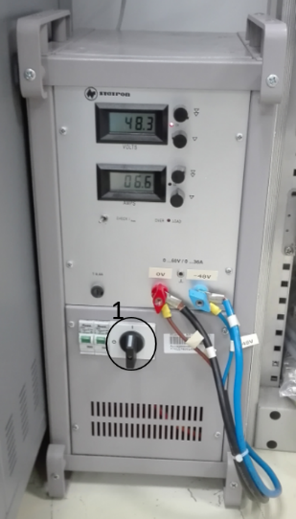

Figure 2. The Keysight M8195A with all relevant connections.

### Yenista OSICS Band C/AG TLS Laser

This is the optical source that will produce the light to be modulated by the 22.5 GHz IQ Modulator. It is mounted on the Nettest OSICS Mainframe. The laser to be used is the only Band C/AG in the mainframe.

Using APC fibers, connect the laser source to the IQ Modulator optical *IN*, placing a polarization controller between them. Make sure that the source is connected to a power source but do not turn on the laser source yet.

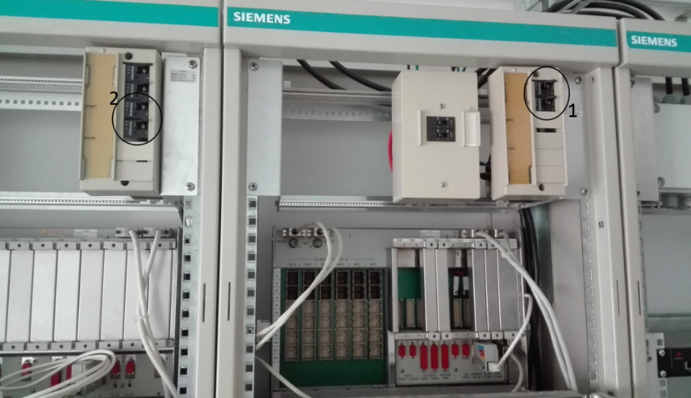

Figure 3. NE switches.

### 22.5 GHz IQ Modulator

The IQ Modulator will be responsible for modulation the optical signal from the input sent by the AWG. By this point it should already be connected to the AWG and the laser source. Mas sure it is also connected to a power source. Two more connections are required. First, using a USB-A to USB-B cable, connect the instrument’s *BIAS control* USB port to the computer where the bias control software is installed. Lastly, connect the input of the USB-controlled VOA to the OUT port of the IQ Modulator. The input cord of the VOA is signaled by an arrow pointing toward the VOA. This connection to the VOA will allow changing the signal-to-noise ratio of the signal, by controlling the power of the modulated signal sent to the EDFA. For this purpose, connect the output of the VOA to *Input A* of the EDFA.

### Constelex Hydra-C-17-17 EDFA

The EDFA amplifies the modulated signal at its input while also acting as a noise source. By changing the power of the signal at its input, the signal-to-noise ratio can be controlled, which is a requirement to measure the Bit-Error-Rate curves. For this purpose, the *Output A* should be connected to the common port of the 200G DWDM. The DWDM will filter the noise produced by the EDFA, limiting its range to 200 GHz around the 1550.12 nm wavelength. This should allow the modulated signal to pass along with some noise in the desired range, while limiting noise power in the rest of the spectrum. The pass port of the DWDM should then be connected to the *Input B* port of the EDFA, in order to amplify the signal further, along with the noise in the desired frequency range. The *Output B* port of the EDFA should then be connected to the *IN* port of the 1x2 90/10 Coupler.

### Apex Technologies AP-2043B Optical Spectrum Analyzer

The Optical Spectrum Analyzer will be used to view the optical spectrum of the modulated signal. This can give insight about the signal status and the presence of some issues. For instance, it is necessary to view the profile to be sure the parameters in the bias controller software are correct, or to measure the optical signal-to-noise ratio. Make sure that the Optical Spectrum Analyzer is connected to a power source.

Connect a PC fiber from the *10* port in the 90/10coupler to the *FC/PC Input* in the Optical Spectrum Analyzer front panel. This way, the optical power diverted to the OSA is small compared to the transmitted signal.

### 100G WDM, Optical Attenuator, Power Monitor

These components serve several purposes. The 100G WDM should serve a similar purpose to the 200G DWDM, but with a narrower bandwidth. The should still be unnecessary noise in remaining from the second stage of the EDFA, and removing it reduces the overall power of the signal to the modulated signal and additive noise in a 100GHz bandwidth. This is also where the attenuation in the power of the optical signal with additive noise is controlled. Although the optical signal-to-noise ratio is controlled and measured in previous parts of the system, this is still important, as it allows measuring and reducing the effective power that reaches the coherent receiver, which requires the input power of the modulated signal to be lower than -6 dBm.

The WDM uses SC connectors, which cannot directly connect to the other ports or patch cords used. As such, adapters and auxiliary patch cords are required. Using the required adapters and patch cords, connect the *90* port in the 1x2 90/10 coupler, which has a PC interface, to the *Common* port of the WDM. Then connect the *Pass* portof the WDM to the VOA attached to the power monitor, which also uses a PC interface.

### Emcore CRTND3U02D ECL Laser

This laser source will be used as a Local Oscillator for the demodulation process on the coherent receptor*. Unlike the other instruments it should be turned on prior to connecting it to the coherent receptor. This is because when first turned on it always defaults to an optical power of 15 dBm, whereas the maximum allowed input at the coherent receiver is +15 dBm. While the optical output is not superior to the stipulated maximum, fluctuations could easily make the value cross the threshold. Therefore, it’s best to always connect this laser source to an optical power meter before connecting it to the coherent receptor, to make sure the value is changed to a lower value.*

To do this, connect a PC fiber to the laser source optical output, while connecting the other end to the *LO PC* +15 dBm optical connection at the coherent receiver. In addition, connect an USB-A to USB-B cable to the laser source’s USB-B port, while connecting the other end to the computer with the laser controller software.

Afterwards, turn on the laser at the physical button, after making sure it is connected to a power source. The laser still won’t start emitting until it is turned ON on the software. Special attention should be given when using the software, as when it is first started, the optical output power is possibly different from the selected value, defaulting to its maximum. To avoid this, after starting the device software and selecting the correct *COM* port, the value for the output power must first be changed before loading the operating parameters to the laser. This is done on the right section of the software. Changing to any valid value different from the currently chosen one will do. Afterwards, change the output power to +12 dBm and press the *LOAD* button.

The correct wavelength also needs to be selected. In order to do this, press the wavelenght button on the left section of the software until the frequency selection changes to wavelength. Then input the 1550.12 value on the box and press the load button. The laser should now be configured and ready to start operation.

### Picometrix CR-100D Coherent receptor

The coherent receptor is responsible for the acquisition and demodulation of the optical signal. Make sure that it is connected to a power source. It requires optical connections from the optical signal source and from a local oscillator, both mentioned before. The optical power at their input connections should be maintained below the maximum values of -6 dBm and +15 dBm, respectively.

After making sure that the signal output power is below the -6 dB when the signal laser source is turned on, connect the fiber from the power monitor to the *IN PC* -6 dBm optical connection. The local oscillator should already be connected according to the previous subsection.

Using two SMK cable connect the *YI* and *YQ* outputs of the coherent receptor to oscilloscope channels 1 and 3.

### Tektronix DPO77002SX-R3 oscilloscope

All the relevant physical connections to the oscilloscope should be done by this point. These are the *Ref Clock Out*, which should be connected to the AWG, providing a common clock signal; and the two channels, 1 and 3, which should be connected to the coherent receptor. Verify that the protector ATI cover is also in place, covering channel 2.

## Turning on and configuring the instruments

After everything is properly connected, start by turning on both computers, the AWG, the IQ Modulator, the Nettest OSICS Mainframe, the EDFA, the OSA, the Coherent Receptor, the Emcore CRTND3U02D ECL Laser and the Oscilloscope. After everything is up and running, you should be able to see that the power monitor stays turned off, the coherent receptor shows no power in any of the outputs and the oscilloscope shows only noise. This is because some devices still require configuration and need to be enabled.

At this point turn the variable attenuator attached to the power monitor clockwise to increase he attenuation of the arriving signal. This will prevent any unexpectedly high signal from reaching the coherent receptor, which has a maximum input power of -6 dBm. When the devices are connected, it can be dialed down to a more suitable value.

### Arbitrary waveform generator Keysight M8195A

Using the peripherals connected to the AWG, press the connect button. The main control screen should then become visible.

Select the *Clock* tab to configure the AWG clock. Here, where it shows *Reference Clock In* select the range “10 to 300 MHz”, input the value 10 and close the circuit by clicking on the switch. This will set the AWG to use the clock from the Oscilloscope for reference.

Next, go to the *Output* tab. Here the AWG outputs will be selected and configured. For both channel 1 and 4, click on the *Enabled* checkbox and set their amplitude to 300 mV.

Lastly, go to *Complex Modulated Waveform* tab. This tab allows configuring the generated waveform. The values chosen here will be mostly used for testing and configuring the system, as the actual waveforms used will be uploaded to the instrument. However, for now it is useful to use this to verify that everything is working and to help configure the other instruments.

Select channel 1 to I and channel 4 to Q, and verify that the checkbox *Generate I/Q Data* is ticked. Next, select “PSK” on *Mod. Scheme*, “QPSK” on *Mod. Type*, and 24 GBaud on the symbol rate.

On *Pulse Shaping* select “Root Raised Cosine”, and set *Alpha* to “0.05”, and *Data Source* to “PBRS 215”. The device should now be ready to start sending the modulation signals to the IQ Modulator.

### Arbitrary waveform generator Keysight M8195A

Using the peripherals connected to the AWG, press the connect button. The main control screen should then become visible. Select the *Clock* to configure the AWG clock. Here, where it shows *Reference Clock In* select the range “10 to 300 MHz”, input the value 10 and close the circuit by clicking on

**TODO**

## Experimental procedure

In Figures 6(a) and 2(b), we present functional diagrams of the two experimental scenarios that will be tested at this stage of the lab work.

* First, we will start by placing the ANT-5 in series with the STM-16 card, with a variable optical attenuator (VOA) placed between the card transmitter and the ANT-5 receiver (see Figure 6(a)). The ANT-5 will be responsible for simultaneously generating and analyzing the traffic.
* Next, we will place the VOA between the ANT-5 transmitter and the STM-16 card receiver. In order to limit the input power in the ANT-5 receiver, you must protect it with a 10 dB fixed attenuator (see Figure 6(b)).

|  |  |
| --- | --- |
| **SDH Model (1)**  **(a)** | **SDH 2 Model (1)**  **(b)** |

Figure 6. Test of an STM-16 card, where the variable optical attenuator placed: (a) before the ANT-5 receiver; (b) after the ANT-5 transmitter.

To proceed experiment, follow the steps given in the sections A, B, and C:

1. **Assemble the experimental setup as shown in Figure 6(a) and follow the steps given below:**
2. Open the «TMNS-CT» management software in PC1 (server PC) (Start->TNMS-CT). Log in using the password tnmsct3.0 (Figure 7).

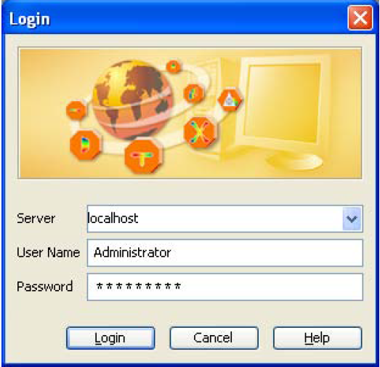

Figure 7. Login in TNMS-CT as a system administrator.

1. Open the NE-5 (Network Element 5) that corresponds to the SMA16/4 cabinet, by double-clicking over its icon, or by pressing the right mouse button + Start Element Manager (see Figure 8).

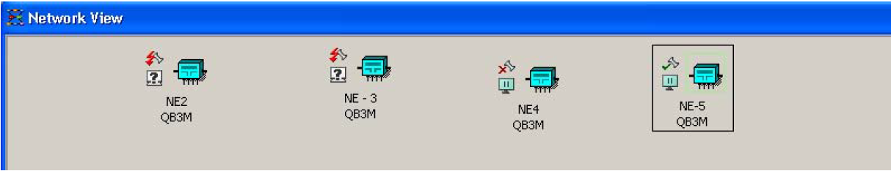

Figure 8. Connecting to SMA16/4 through TNMS-CT.

1. After opening the SMA16/4 management interface, the Module View shall look like Figure 9 (with LOS alarm in the OIS16D card due to loss of signal).

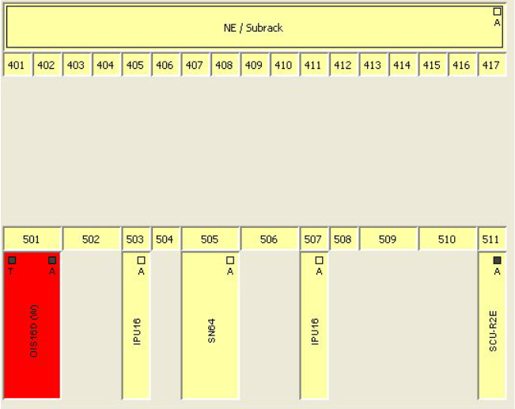

Figure 9. Module View of SMA16/4 connecting with NE-5.

1. Connect the ANT-5 to the STM-16 card in accordance with Figure 6(a), interleaving the variable optical attenuator between the ANT-5 receiver and the transmission fiber coming from the OIS16D card.
2. Confirm that the sent signal structure in the ANT-5 matches the one shown in Figure 10.

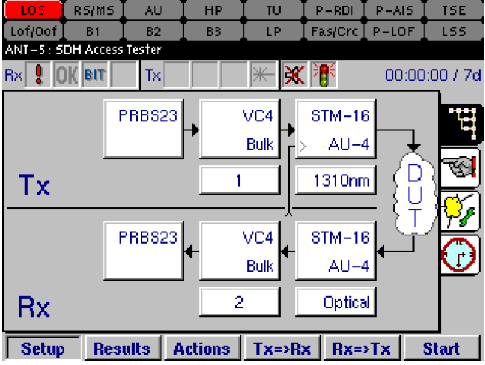

Figure 10. Configuring the ANT-5 for communication with the STM-16 card.

1. Turn on the ANT-5 laser (Figure 11).

|  |  |
| --- | --- |
| seU5TP_EwCk | WEXBCaAmmBo  **Enter**  **Enter** |

Figure 11. How to turn on the laser.

1. After properly configuring all the equipment, both the ANT-5 and the SMA16/4 management software shall not present any alarms.
2. **Follow the steps given below to perform a BERT analysis using the ANT-5. From the obtained data, draw graphics of the bit error rate as a function of optical power:**
3. Switch the optical attenuator to the signal wavelength sent by the ANT-5 (1310 nm).
4. Adjust the attenuation in the VOA to approximately -29 dBm at the ANT-5 input, which is the expected received optical power value at which there are non-zero bit error rates.
5. In the Repetitive BERT tab, in the results page, click on Start to initiate the BER analysis (see Figure 12).

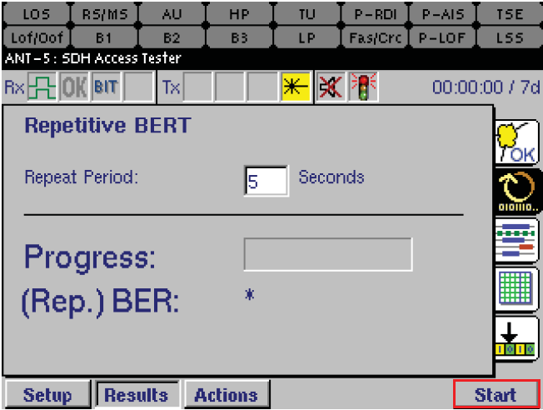

Figure 12. Initiate BER analysis no ANT-5.

1. Navigate to the results summary page and carry on the BERT analysis for 15 seconds (see Figure 13).

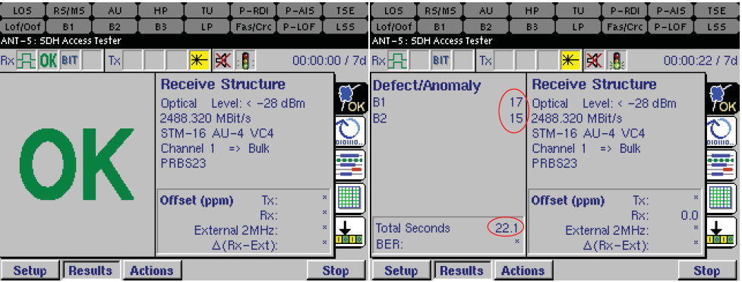

Figure 13. Results Summary page.

1. After 15 seconds of the test, terminate the BERT analysis by clicking on Stop (see Figure 14).

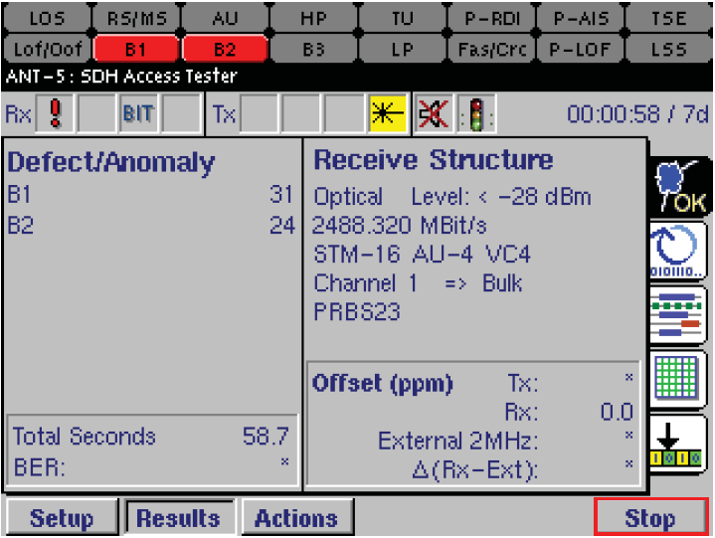

Figure 14. Stop the BER test.

1. Gradually increase the attenuation in steps of 0.5 dB, repeating the procedure of points (III) to (VI) for each attenuation value.
2. End up the tests when the loss of signal (LOS) alarm is displayed (approximately - 32 dBm).
3. With the obtained data, draw a graph depicting the evolution of the bit error rate as a function of the signal power in the variable optical attenuator output. In this graph, identify the loss of signal region, the no error region and the region where the errors are proportional to signal power.
4. Justify the results obtained on the graph by explaining why it is possible to see the three regions described above.
5. **Assemble the experimental setup of Figure 6(b) and proceed similarly to what has been done in section B:**
6. Turn off the ANT-5 laser and place the variable optical attenuator between the ANT-5 transmitter and OIS16D card receiver, as shown in Figure 6(b). In this scenario, we need to use a fixed 10 dB optical attenuator before the ANT-5 receiver in order to prevent possible damages due to high optical powers.
7. Repeat the procedure of points (I) to (IX) discussed in section **B**. This time, perform the BER analysis with the received optical power values between -22 dBm and -27 dBm.
8. Comparing the obtained results in section **B** and **C**, what can you conclude about the sensitivity of both the ANT-5 and the STM-16 card receivers?

## Obtained results

|  |  |  |  |
| --- | --- | --- | --- |
| **Case 1 (Figure 6(a))** | | **Case 2 (Figure 6(b))** | |
| **Received Power in dBm** | **BER** | **Transmitted Power in dBm** | **BER** |
| -27 | 0 | -18.3 | 0 |
| -28 | 3.79e-9 | -19 | 1.33e-9 |
| -28.5 | 1.38e-8 | -19.5 | 3.072e-8 |
| -29 | 1.49e-7 | -20 | 7.59e-7 |
| -29.5 | 8.89e-7 | -20.5 | 5.24e-6 |
| -30 | 4.08e-6 | -21 | 4.77e-5 |
| -30.5 | 2.38e-5 | -21.5 | 2.01e-4 |
| -31 | 7.29e-5 | -22 | 8.31e-4 |
| -31.5 | **LOS** | -22.5 | 2.61e-3 |
| -- | -- | -23 | 5.47e-3 |
| -- | -- | -23.5 | 1.34e-2 |
| -- | -- | -24 | 2.25e-2 |
| -- | -- | -25 | 3.95e-1 |
| -- | -- | -25.5 | **LOS** |